# Dataset : https://www.kaggle.com/c/house-prices-advanced-regression-techniques

# Load the data

Let’s load the Kaggle dataset into a Pandas data frame:

df_train = pd.read_csv('house_prices_train.csv')

# Exploration — getting a feel for our data

We’re going to predict the SalePrice column ($ USD), let’s start with it:

count 1460.000000

mean 180921.195890

std 79442.502883

min 34900.000000

25% 129975.000000

50% 163000.000000

75% 214000.000000

max 755000.000000

Name: SalePrice, dtype: float64

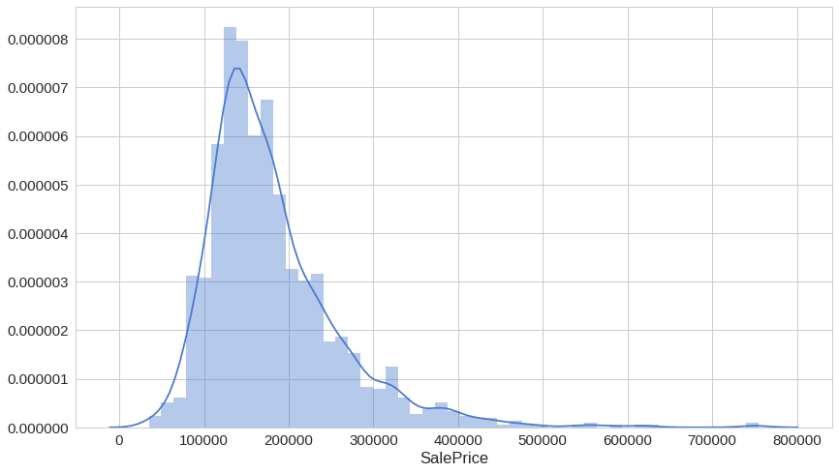

Most of the density lies between 100k and 250k, but there appears to be a lot of outliers on the pricier side.

Next, let’s have a look at the greater living area (square feet) against the sale price:

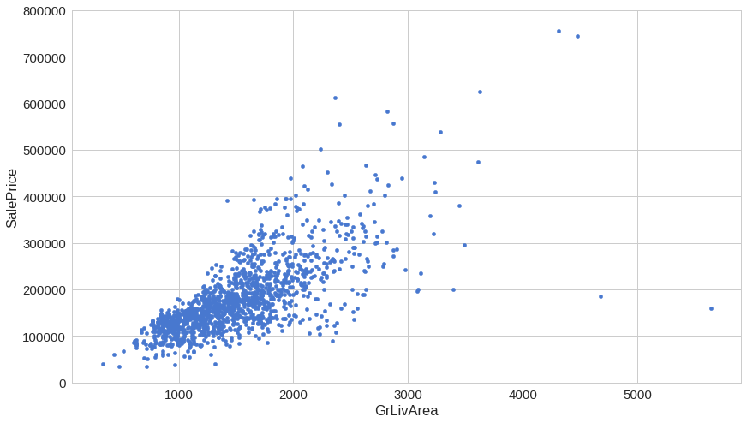

You might’ve expected that larger living area should mean a higher price. This chart shows you’re generally correct. But what are those 2–3 “cheap” houses offering huge living area?

One column you might not think about exploring is the “TotalBsmtSF” — Total square feet of the basement area, but let’s do it anyway:

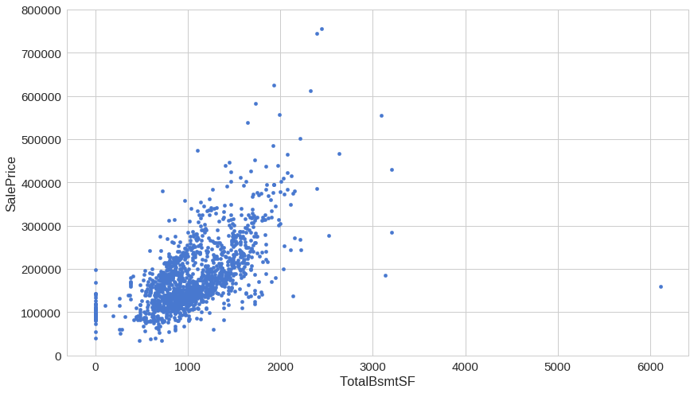

Intriguing, isn’t it? The basement area seems like it might have a lot of predictive power for our model.

Ok, last one. Let’s look at “OverallQual” — overall material and finish quality. Of course, this one seems like a much more subjective feature, so it might provide a bit different perspective on the sale price.

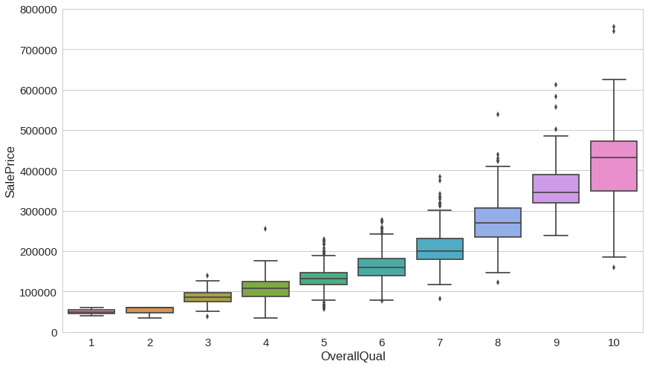

Everything seems fine for this one, except that when you look to the right things start getting much more nuanced. Will that “confuse” our model?

Let’s have a more general view on the *top 8* correlated features with the sale price:

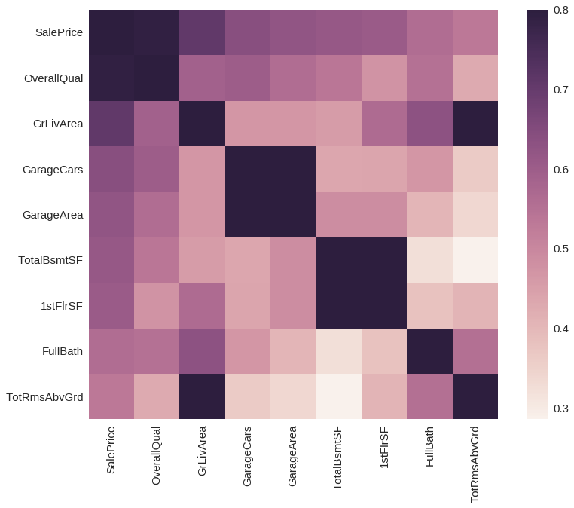

Surprised? All the features we discussed so far appear to be present. Its almost like we knew them from the start…

## Do we have missing data?

We still haven’t discussed ways to “handle” missing data, so we’ll handle them like a boss — just not use those features:

| | Row count | Percentage |

|--------------|-----------|------------|

| PoolQC | 1453 | 0.995205 |

| MiscFeature | 1406 | 0.963014 |

| Alley | 1369 | 0.937671 |

| Fence | 1179 | 0.807534 |

| FireplaceQu | 690 | 0.472603 |

| LotFrontage | 259 | 0.177397 |

| GarageCond | 81 | 0.055479 |

| GarageType | 81 | 0.055479 |

| GarageYrBlt | 81 | 0.055479 |

| GarageFinish | 81 | 0.055479 |

| GarageQual | 81 | 0.055479 |

| BsmtExposure | 38 | 0.026027 |

| BsmtFinType2 | 38 | 0.026027 |

| BsmtFinType1 | 37 | 0.025342 |

| BsmtCond | 37 | 0.025342 |

Yes, we’re not going to use any of those.

# Predicting the sale price

Now that we have some feel of the data we’re playing with we can start our plan of attack — how to predict the sale price for a given house?

## Using Linear Regression

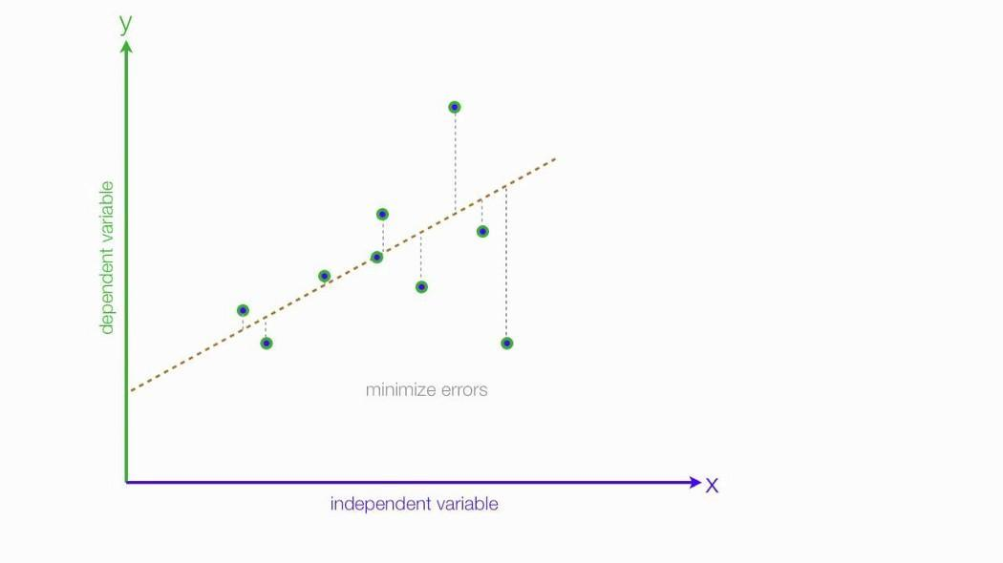

source: [http://mybooksucks.com](http://mybooksucks.com/)

Linear regression models assume that the relationship between a dependent continuous variable Y and one or more explanatory (independent) variables X is linear (that is, a straight line). It’s used to predict values within a continuous range (e.g. sales, price) rather than trying to classify them into categories (e.g. cat, dog). Linear regression models can be divided into two main types:

## Simple Linear Regression

Simple linear regression uses a traditional slope-intercept form, where *a* and *b* are the coefficients that we try to “learn” and produce the most accurate predictions. *X* represents our input data and *Y* is our prediction.



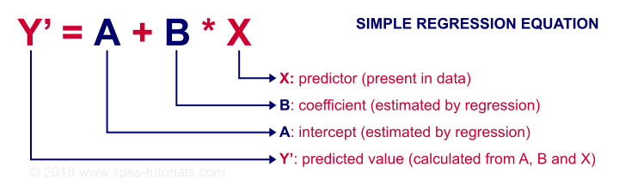

source: [https://spss-tutorials.com](https://spss-tutorials.com/)

## Multivariable Regression

A more complex, multi-variable linear equation might look like this, where *w* represents the coefficients or weights, our model will try to learn.



The variables x_1, x_2, x_3 represent the attributes or distinct pieces of information, we have about each observation.

# Loss function

Given our Simple Linear Regression equation:



We can use the following cost function to find the coefficients/parameters for our model:

## Mean Squared Error (MSE) Cost Function

The MSE is defined as:



where



The MSE measures how much the average model predictions vary from the correct values. The number is higher when the model is performing “bad” on our training data.

The first derivative of MSE is given by:



## One Half Mean Squared Error (OHMSE)

We will apply a small modification to the MSE — multiply by *1/2* so when we take the derivative, the *2s* cancel out:



The first derivative of OHMSE is given by:



Let’s implement it in Python (yes, we’re going TDD style!)

| class TestLoss(unittest.TestCase): |  |
| --- | --- |
|  |  |
|  | def test_zero_h_zero_y(self): |
|  | self.assertAlmostEqual(loss(h=np.array([0]), y=np.array([0])), 0) |
|  |  |
|  | def test_one_h_zero_y(self): |
|  | self.assertAlmostEqual(loss(h=np.array([1]), y=np.array([0])), 0.5) |
|  |  |
|  | def test_two_h_zero_y(self): |
|  | self.assertAlmostEqual(loss(h=np.array([2]), y=np.array([0])), 2) |
|  |  |
|  | def test_zero_h_one_y(self): |
|  | self.assertAlmostEqual(loss(h=np.array([0]), y=np.array([1])), 0.5) |
|  |  |
|  | def test_zero_h_two_y(self): |
|  | self.assertAlmostEqual(loss(h=np.array([0]), y=np.array([2])), 2) |

Now that we have the tests ready, we can implement the loss function:

|  | def loss(h, y): |
| --- | --- |
|  | sq_error = (h - y)**2 |
|  | n = len(y) |
|  | return 1.0 / (2*n) * sq_error.sum() |

run_tests()

time for the results:

.....

--------------------------------------------------------------

Ran 5 tests in 0.007s

OK

## Data preprocessing

We will do a little preprocessing to our data using the following formula (standardization):



where µ is the population mean and σ is the standard deviation.

But why? Why would we want to do that? The following chart might help you out:

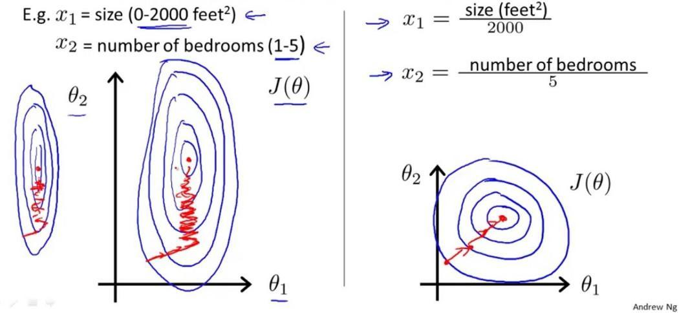

What the doodle shows us that our old friend — the gradient descent algorithm, might converge (find good parameters) faster when our training data is scaled. Shall we?

|  | x = df_train['GrLivArea'] |
| --- | --- |
|  | y = df_train['SalePrice'] |
|  |  |
|  | x = (x - x.mean()) / x.std() |
|  | x = np.c_[np.ones(x.shape[0]), x] |

We will only use the greater living area feature for our first model.

## Implementing Linear Regression

First, our tests:

|  | class TestLinearRegression(unittest.TestCase): |
| --- | --- |
|  |  |
|  | def test_find_coefficients(self): |
|  | clf = LinearRegression() |
|  | clf.fit(x, y, n_iter=2000, lr=0.01) |
|  | np.testing.assert_array_almost_equal(clf._W, np.array([180921.19555322, 56294.90199925])) |

Without further ado, the simple linear regression implementation:

|  | class LinearRegression: |
| --- | --- |
|  |  |
|  | def predict(self, X): |
|  | return np.dot(X, self._W) |
|  |  |
|  | def _gradient_descent_step(self, X, targets, lr): |
|  |  |
|  | predictions = self.predict(X) |
|  |  |
|  | error = predictions - targets |
|  | gradient = np.dot(X.T, error) / len(X) |
|  |  |
|  | self._W -= lr * gradient |
|  |  |
|  | def fit(self, X, y, n_iter=100000, lr=0.01): |
|  |  |
|  | self._W = np.zeros(X.shape[1]) |
|  |  |
|  | for i in range(n_iter): |
|  | self._gradient_descent_step(x, y, lr) |
|  |  |
|  | return self |

You might find our Linear Regression implementation simpler compared to the one presented for the Logistic Regression. Note that the use of the Gradient Descent algorithm is pretty much the same. Interesting, isn’t it? A single algorithm can build two different types of models. Would we be able to use it for more?

run_tests()

......

----------------------------------------------------------------- Ran 6 tests in 1.094s

OK

## Predicting the sale price with our first model

Let’s use our freshly created model to begin our housing market domination:

|  | clf = LinearRegression() |
| --- | --- |
|  | clf.fit(x, y, n_iter=2000, lr=0.01) |

So how did the training go?

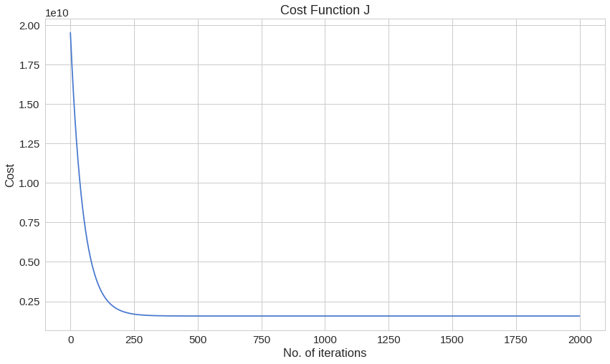

Our cost, at the last iteration, has a value of:

1569921604.8332634

Can we do better?

# Multivariable Linear Regression

Let’s use more of the available data to build a *Multivariable Linear Regression* model and see whether or not that will improve our OHMSE error. Let’s not forget that scaling too:

|  | x = df_train[['OverallQual', 'GrLivArea', 'GarageCars']] |
| --- | --- |
|  |  |
|  | x = (x - x.mean()) / x.std() |
|  | x = np.c_[np.ones(x.shape[0]), x] |

## Implementing Multivariable Linear Regression

*This space is intentionally left (kinda) blank*

## Using Multivariable Linear Regression

Now that the implementation of our new model is done, we can use it. Done!?

You see, young padawan, the magical world of software development has those mythical creates called ***abstractions***. While it might be extraordinarily hard to get them right, they might reduce the complexity of the code you write by (pretty much) a ton.

You just used one such abstraction — called [***vectorization***](https://www.oreilly.com/library/view/python-for-data/9781449323592/ch04.html). Essentially, that allowed us to build a *Multivariable Linear Regression* model without the need to loop over all features in our dataset. Neat, right?

Our client interface stays the same, too:

|  | clf = LinearRegression() |
| --- | --- |
|  | clf.fit(x, y, n_iter=2000, lr=0.01) |

And the results:

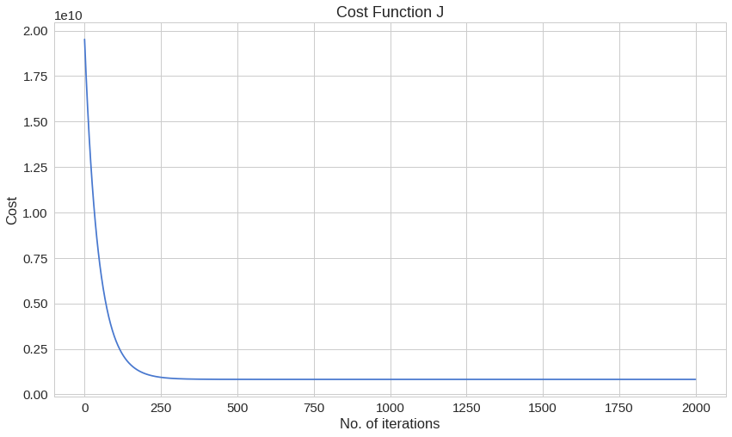

822817042.8437098

## **References**

Analytics Vidhya. 2021. *30 Questions to test a data scientist on Linear Regression*. [online] Available at: <https://www.analyticsvidhya.com/blog/2017/07/30-questions-to-test-a-data-scientist-on-linear-regression/> [Accessed 31 October 2021].

Machinelearningplus.com. 2021. [online] Available at: <https://www.machinelearningplus.com/python/101-pandas-exercises-python/> [Accessed 31 October 2021].

Medium. 2021. *Andrew Ng’s Linear Regression Exercise (Week 2) — A Python Solution*. [online] Available at: <https://medium.com/@chex2chex/andrew-ngs-linear-regression-exercise-week-2-a-python-solution-5809ff4379b9> [Accessed 31 October 2021].

Medium. 2021. *Predicting House Prices with Linear Regression | Machine Learning from Scratch (Part II)*. [online] Available at: <https://towardsdatascience.com/predicting-house-prices-with-linear-regression-machine-learning-from-scratch-part-ii-47a0238aeac1> [Accessed 31 October 2021].